PHYSICAL SCIENCES – ATMOSPHERIC AND PLANETARY SCIENCES

Kinetic limitations on attaining equilibrium for a model aerosol composition.

*1A. Murray Booth, 2,3Ben Murphy, 2Ilona Riipinen, 1Carl J. Percival, 1David O. Topping,*

*1School of Earth, Atmospheric and Environmental Science, University of Manchester, Manchester, U.K.*

*2Department of Applied Environmental Science and Bolin Centre for Climate research, Stockholm University, Stockholm, Sweden*

*3Department of Meteorology and Bolin Centre for Climate research, Stockholm University, Stockholm, Sweden*

Corresponding Author:

Alastair Murray Booth

+44 (0)1613066857

4.60, Simon Building

Oxford Road

Manchester

M13 9PL

United Kingdom

[Murray.booth@manchester.ac.uk](mailto:Murray.booth@manchester.ac.uk)

**Abstract**

The growth, composition, and evolution of secondary organic aerosols (SOA) are governed by properties of individual compounds and ensemble mixtures that affect partitioning between the vapour and condensed phase. There has been considerable recent interest in the idea that SOA can form highly viscous particles where the diffusion of either water or semivolatile organics within the particle is sufficiently hindered to affect evaporation and growth. Despite numerous indirect inferences of viscous behaviour from SOA evaporation or ‘bounce’ within aerosol instruments, there have been no bulk measurements of the viscosity of well-constrained model aerosol systems of atmospheric significance. Here the viscous behaviour of a well-defined model system of 9 dicarboxylic acids is investigated directly with complimentary measurements and model predictions used to infer phase state. Results not only allow us to discuss the atmospheric implications for SOA formation, but also the potential impact of current methodologies used for probing this affect in both the laboratory and from a modelling perspective. We show that where current methodologies might force the derived physical state from amorphous solid to liquid, the volatility range of compounds for which mixing timescales become a limiting factor change by 8 orders of magnitude for a 100nm diameter particle. Recommendations for future research directions are given.

.

**Significance statement**

Aerosol particles cause significant health impacts and they represent a huge uncertainty in our understanding of climate change. Now thought to exist as highly viscous media, limitations on mixing within a particle can effect the transfer of molecules between the gas and particle phase and thus evolving impacts. In this paper the viscosity and physical state of proxy mixtures for aerosol particles are measured using complimentary methods and converted into diffusion coefficients. We show that existing methodologies could force derived physical state of relevant systems with huge impacts on derived impacts. We show that using a directly measured amorphous solid viscosity or an extrapolated liquid-like value changes the volatility range of compounds for which mixing timescales in the bulk become the limiting step by 8 orders of magnitude for a 100nm particle.

**Introduction**

A significant fraction of atmospheric aerosol particles are comprised of organic material (20-90% of particle mass) (1), containing potentially thousands to hundreds of thousands of compounds with largely uncertain physico-chemical properties. Traditionally, two assumptions have often been made about the physical state in order to calculate gas-aerosol interactions (e.g. condensational growth and water uptake) and lifetime; 1) the aerosol phase is a well-mixed non-viscous liquid; 2) the aerosol phase instantaneously equilibrates with the gas phase constituents. However, it is becoming increasingly evident that organic aerosols may exist as metastable amorphous states in atmospheric conditions, rather than simple liquid/solid mixtures (2). Indeed, empirical evidence suggests that some SOA particles can form glass-like substances (3). This has several important implications for climatic and health effects of organic aerosol: The low diffusivity of water within an aerosol particle might influence its ability to grow in a humid environment and thus affect the direct and indirect climatic effects (4); the low diffusivity of individual organic molecules in solid/amorphous organic mixtures could directly affect their mass transfer, and thus the loading and composition whilst ice nucleation has been observed to be suppressed (5). The large potential impact on gas-to-particle partitioning combined with our relatively poor understanding of viscous behaviour in aerosol particles necessitates the fundamental study of well-defined model systems of atmospheric relevance, in order to resolve our ability to truly determine the magnitude of these effects. Much of our understanding has been inferred from indirect measurements. This is the first direct bulk rheological study of an atmospherically relevant system combined with compound dependent model predictions for probing the impact of phase state.

In figure 1, an aerosol particle changes size and composition by mass transfer of its constituent molecules (red) between the condensed phase and the gas phase according to the concentration in the gas phase, the equilibrium vapour pressure above the solution and accommodation coefficient of each condensate. In order to achieve equilibrium between the gas and bulk particle composition however, molecules from the core of the aerosol particle must be free to diffuse from the interior to the surface where mass transfer occurs. Any limitation on this diffusion will impact the time it takes to reach equilibrium and hence the size, composition, and water content, for example, of the aerosol particle. Figure 1b (6) illustrates the impact of different translational self-diffusion coefficients within an aerosol particle, Dp, calculated using the Stokes-Einstein relationship (see below) and a molecular radius of 1nm, as a function of aerosol particle diameter. The graph shows diagonal lines of constant mixing time scales. For example water in both a 10 nm particle with a Dp of 10-15 cm2 s-1 and a 10 µm particle with a Dp of 10-9 cm2 s-1 will take about 1 min to reach homogeneous concentration of the diffusing species in the condensed phase. Viscosity (η) and diffusion (Dp) are intimately linked, according to several modelling frameworks, the most popular being the Stokes-Einstein equation:

$D_{p}=\frac{kT}{6πηr}$ (1)

where r is the hydrodynamic radius of the diffusant. The graph displays the viscosity corresponding to a given diffusion coefficient assuming the Stokes-Einstein relation is valid. Unfortunately, numerous studies have highlighted the Stokes-Einstein relation to be valid for only infinite dilution conditions (7), despite its continued use in atmospheric impact studies. Nonetheless, alternative correlative methods remain largely untested. The graph is divided (according to the viscosity) into coloured regions that indicate when the particle is liquid, semi-solid and solid to give an easier understanding of the levels of viscosity encompassed. Conceptually, the time scales indicate the time that it takes for particles to reach a homogeneous composition between surface and bulk composition. The ratio of this time scale as compared with the characteristic evaporation time scale determines whether the internal diffusion needs to be explicitly taken into account when calculating the gas-aerosol interactions (see 8; 9). Unlike existing studies on this process, we use this approach for defining broad ranges of SOA volatilities, in terms of their C* value (10), for which condensed diffusion might need to taken into account to focus future investigations. With this work we have combined this approach for the first time with direct, rather than inferred, bulk viscosity measurements of a well defined atmospherically relevant system to improve our understanding at a fundamental level.

**Results**

To understand the potential impacts of kinetic limitations in the particulate phase, viscosity measurements of bulk proxies for secondary organic aerosol (SOA) were studied which are then related to diffusion coefficients and mixing times. Bulk measurements allow us to probe specific material properties of aerosol forming material and it allows the utilisation of techniques that have been refined from other fields. They also allow us to study a well-constrained system to test property estimation methods with. The model system chosen is an equimolar mixture of the C3-C10 & C12 dicarboxylic acids as used by Cappa (11) which were constructed as a representative mixture of atmospheric organic aerosols. As noted in previous investigations (12,13,14), studies should attempt to focus on mixtures that are more complex than binary and ternary solutions as sensitivities to multiple properties can change and thus have implications for atmospheric aerosol. Dicarboxylics are ubiquitous in the atmosphere (15) and have been identified in marine, urban and arctic environments. Their abundance makes them an ideal subset of compounds for bulk studies of aerosol properties. The samples were also prepared with increasing mole fractions of water to probe how humidity might influence viscosity.

Figure 2 shows the change in dynamic viscosity as a function of temperature for the non-aqueous diacid mix. It has a viscosity of around 6 × 106 Pa s at room temperature, which from fig 1b and assuming a 1nm compound within the Stoke-Einstein equation corresponds to a diffusion coefficient of ~10-14 cm2 s-1. Depending on particle size, the impact on mixing times will be extremely important. For a 10 nm particle, a mixing time of ~1 s is not significant, but for a 2.5 micron particle the mixing time is several days, and for a 10 micron particle it is more than a month, longer than the atmospheric lifetime of most tropospheric aerosols.

Important questions arise from these values: What state is the mixture in? How representative is this state for atmospheric implications? How valid are the retrieved diffusion coefficients? By adding additional analytical procedures and property predictive techniques we can start to answer these questions.

First, mutual melting point depression means the diacid mixture does not solidify at the same temperatures the individual acids do (80˚C for the mix compared to 103˚C for azealic acid and up too 184˚C for succinic acid). Upon heating the bulk diacid mix we observe a rapid decrease in viscosity between 60 and 80˚C that corresponds with a very broad peak in differential scanning caloritmery (DSC) thermograms (see supplementary data) rather than a narrow peak which is characteristic of crystalline to liquid transitions.

Second, well-constrained systems such as the diacid mix allow us to validate property estimation methods on molecules and functional groups relevant to atmospheric science which are often quite different to those used to train such group contribution methods. Here we use a pure component viscosity estimation method based on the group contribution method of Nannoolal (16), in the same fragmentation pattern that is employed for estimating the vapour pressures of compounds in SOA (17). The pure component viscosities are combined with mixing rules from GC-UNIMOD (18) and Bosse (19) (see supplementary information). The 298.15 K prediction of 0.74 Pa s for GC-UNIMOD and 0.34 Pa s for Bosse are approximately 7 orders of magnitude too low (see figure 2) for the diacid mix. It is the failure to predict the state correctly which causes such a wide discrepancy telling us the sample is different to the presumed liquid state of the model. The bulk mix can be supercooled by 20-30˚C before the phase change occurs and experiments by Cappa (11) show that aerosol particles generated from the diacid mix behave as (non-ideal) liquids over the timescale of a lab experiment (at least a few hours). Further measurements of the viscosity at higher temperatures using a different plate geometry allow us to extrapolate the liquid state viscosity down to room temperature. This shows the estimation method is far closer to the measured value if the particle is in a supercooled liquid state, 0.34 Pa s for Bosse compared with an extrapolated measured value of 0.17 Pa s. This is much lower than the measured 6 × 106 Pa s indicating the sample is not a meta-stable liquid.

Third, the crossover in the elastic and loss modulus (G’ and G’’ as shown in figure 3) that are the in phase and out of phase response to the rheometer driving force. The crossover indicates a phase transition where solid-like properties are beginning to dominate over liquid-like. IR spectra on our bulk sample show no chemical change and power x-ray diffraction of the solid phase show it to be amorphous (see suplementary material).

Fourth, upon rapid cooling, many liquid compounds can undergo a non-equilibrium phase transition to solid non-crystalline state known as a glass (far left on fig 1b). At cooling rates likely to be encountered in the atmosphere (i.e. ~5˚C min‑1 for a particle in strong convection updraft of 10 ms-1 and an adiabatic lapse rate of 7˚C km-1) there was no evidence of any glass formation for this mixture from either DSC where glass transitions appear as step changes in the heat capacity or from viscosity measurements where they appear as step changes in G’ and a peak in tan δ, the phase angle between the rheometer driving force and response (see supplementary material).

The lack of regular structure or glass behaviour suggested that the solid phase may be gel-like, with irregular hydrogen bond linkages from the ends of the diacids making it so viscous. The DSC thermograms also show an additional peak around 20˚C that does not have any corresponding rheological change. The temperature range studied and model predictions highlight the drastic change in mixture properties through assumed or experimentally forced physical state. This gives us an upper and lower bound for studying potential impacts on SOA formation through assumptions in condensed phase mixing, as discussed in the next section.

Given the abundance of water vapour in the atmosphere, varying the water content also enables us to investigate potential impacts on retrieved hygroscopicity. From Figure 2, up to water mole factions of 0.8, the viscosity does not drop below 2ˣ106 Pa s. As the water content increases above 0.9 mole fraction, the viscosity decreases another order of magnitude, with the mixture becoming almost ‘slushy’ with what looks like phase separation between the water and organic phase. If the mixture is a gel-like amorphous solid it may be able to incorporate pockets of water within its complex organic matrix which start to compromise the stability (high viscosity) of the mix as the water content increases. In this case the amorphous solid at room temperature cannot efficiently absorb water. If an aerosol particle would be in such a state it might be expected that similar behaviour would occur, thus removing any strong relative humidity dependencies of mass partitioning over a given time frame.

**Implications for gas-aerosol interactions**

To investigate the potential importance of the viscosity and particle-phase diffusivity for calculating the gas-aerosol interactions of organic aerosols (e.g. SOA formation, water uptake and cloud droplet activation), the mixing time scales of the investigated mixture need to be estimated and compared to the evaporation time scales of atmospherically relevant species (such as water and the mixture constituents).

Figure 3 shows the characteristic mixing time for differently sized aerosol particles at increasing water mole fraction at 25˚C, using the Stokes-Einstein relation for the diffusion coefficient, Dp with an organic molecule size of 1 nm and the viscosities measured here for the diacid mixture. The mixing time τ, is given by;

(2)

$$τ={\frac{d_{p}^{2}}{4π^{2}D}}_{p}$$

where dp, is the aerosol particle diameter. Given the observation that the water did not fully mix with the organic matrix at 25C, the lack of variability is not surprising. As expected, times are significant for the very largest particles (10µm) varying from 3 years to just over a week for 0.97 moles of water, whereas below 10 nm, the timescales are at most >1 s assuming the ‘slushy’-like state is also possible in particulate matter. For the viscosities displayed by this mixture, the bulk mixing timescales cover a huge range, from about 0.03 seconds, small compared to the duration of a typical lab experiment, to large enough to dwarf the atmospheric lifetime (more than a year). The impact of bulk mixing time is highly dependent on the context;- in a lab experiment a mixing time of minutes or even seconds may be significant. For work with smog and aerosol chambers timescales of hours may be important, based on our viscosities this would encompass any particles greater than 0.1µm.

In order to directly compare mixing time to evaporation time, we choose to adopt the perspective of a molecule in a monolayer thick surface layer region susceptible to either evaporation from the layer or uptake into the bulk matrix (Fig. 5b). This formulation allows us to address the question of whether the surface composition can be approximated by the bulk composition when calculating the interactions between the aerosol particle and the gas phase. This view necessitates reformulation of the mixing time scale definition. Shiraiwa (6) showed that the average time to cover the distance of the surface layer could be formulated as:

(3)

$$τ=\frac{{(δ+δ_{lay})}^{2}π}{16D_{p}}$$

where δ is the molecule diameter (assumed to be 0.5 nm) and δlay is the thickness of the surface layer (assumed here to be 3 molecules deep). While the functional forms of Eqs. 2 and 3 are similar, they are notably different in magnitude: while the former describes the mixing over the entire particle, the latter is related to the transport over the surface layer just adjacent to the gas phase. In the following Eq. 3 is compared to the evaporation time scale of a single molecule arriving at the surface to study which of the time scales is limiting the time that the molecule spends at the surface.

Figure 4 shows the relationship between particle size, diffusivity and the volatility (expressed as effective saturation concentration in μg m-3) above which the time scale of particle-phase mixing becomes longer than that of evaporation to the gas phase (we hereafter refer to this quantity as the threshold volatility). It shows that for the lowest diffusivities extrapolated from the measured viscosity (from the amorphous state) at room temperature (about 10-15 cm2 s-1), the condensation and evaporation of compounds with saturation concentrations (at 298 K) larger than 10-6-10-2 μg m-3 are likely to be influenced by particulate-phase mixing limitations in accumulation mode particles. To put this low number into context, the saturation concentration of pure water is 2.19 x 107 μg m-3, the saturation concentration of the pure diacids are of the order of 1-10 µg m-3 (17,20), while the saturation concentration of the least-volatile atmospherically relevant organic compounds are less than about 10-3 µg m‑3 (21,22).

It is important to emphasize that the threshold volatility estimates plotted in figure 4 are for *effective* saturation concentration, which is traditionally calculated as a function of the species pure-component saturation concentration (*C*0) modified by the species’ mole fraction (xi) in the condensed phase and the species’ activity coefficient (γi):

(4)

$$C_{i}^{*}=x_{i}γ_{i}C_{i}^{0}$$

If the species is dilute (low mole fraction) or mixing interactions are strongly in favour of condensation (low activity coefficient), then the pure-component threshold volatility estimate will be much larger. On the other hand, if the activity coefficient is large, evaporation is favoured and the threshold volatility will be even smaller. Mixing interactions between organic species and water could be a very important consideration in this context. Highly polar species may experience an overall shift in equilibrium towards condensation upon the addition of water to the particulate phase, thereby increasing the threshold volatility. However, thermodynamic models commonly estimate quite high activity coefficients for nonpolar organics and water, thus decreasing the threshold volatility even further. Under these circumstances, though, it is conceivable that strong driving forces against mixing would lead to phase separation in the particle and bring the effective saturation concentration nearer to that of the pure component. In this light, the threshold volatility estimates could be considered a lower bound. To complement the effect of the amorphous state, figure 4 shows the threshold volatility variability for the extrapolated liquid-like behaviour. Assuming the extrapolation method for estimating diffusivities is valid, the rheometer results yield diffusion coefficients between ~3 x 10-8 and 3 x 10-5 cm2 s-1 for supercooled state/high temperatures (> 100 °C). For accumulation mode particles, this translates to estimated threshold volatilities of about 100-106 µg m-3. In the context of organic aerosol partitioning, these compounds would not condense significantly to the particle phase at atmospherically relevant concentrations. However, in the context of highly concentrated laboratory experiments or of condensation of water, which has far higher atmospheric concentrations, these saturation concentrations become more meaningful. It is also important to note that although the high temperature experimental region reflects viscosities measured at temperatures greater than 100 °C, the threshold saturation concentrations are not corrected in this figure for temperature dependence (i.e. through the Clausius-Clapeyron relationship).

Figure 5 shows the corresponding threshold volatilities at varying water contents, particle sizes and temperatures for species mixing into the diacid-water mixture studied here. The volatility estimates are converted to estimates at 298 K using the Clausius-Clapeyron relationship and assuming an enthalpy of vaporization equal to 100 kJ mol-1 for the condensing species. It can be seen that at ambient temperatures, with the amorphous solid state, low threshold volatilities (C* = 10-2 µg m-3) are estimated for even the smallest particles with the shortest mixing timescales. The volatilities are largely insensitive to water content at low temperatures due to the lack of mixing in the bulk sample, but much more sensitive at high temperatures. Note that 90 °C is on the threshold of liquid-phase behaviour for this system (Fig. 3) and is roughly the diffusivity of the supercooled state. Viscosity measurements at this temperature and water content varied by three orders of magnitude (from 1 to ~1000 Pa s) and may be influenced by the path-dependent melting and solidification processes. Ultimately, this variability leads directly to the threshold volatility variability observed in figure 5c.

The strong mixing limitation estimated by this analysis of bulk measurements perhaps yields insight into past measurements of organic aerosol hygroscopicity. For example, Peng (23,24) found that selected dicarboxylic acids did not exhibit deliquescence when examined with an electrodynamic balance technique under varying relative humidity, thereby contradicting UNIFAC predictions of bulk organic-water interactions (theoretical deliquescence relative humidity > 89%). The authors cited mass transfer limitations as a possible contributing factor, but ruled it out noting that the time dependence for hygroscopic growth of organic particles was identical to that of inorganic sulphate. While our calculations would suggest particulate phase mass transfer to play a role for the hygroscopic growth of diacids, experimental evidence on this remains inconclusive.

Using results from both the amorphous and liquid like state from the same mixture also sheds some light onto the danger of currently prescribing diffusion coefficients from the Stoke-Einstein equation. It remains to be seen which physical state is truly representative of atmospheric aerosol and have variable this might be. It may be that the true diffusion coefficient for a given mixture is somewhere between the two extremes. Similarly, it is not yet been demonstrated that a binary representation of a diffusion coefficient is an accurate representation of diffusion through a matrix of compounds. We would therefore encourage future studies that can directly retrieve diffusion coefficients of a range of compounds through increasingly complex mixtures.

**Conclusion**

This is the first bulk rheological study of a representative ‘complex’ SOA mixture combined with novel impact studies. It shows that at room temperature the representative diacid mix is an amorphous solid with a high viscosity (6ˣ106 Pa s) and remains highly viscous even at increasing water mole fractions. X-ray diffraction shows it is non-crystalline and DSC does not show a glass transition over an atmospherically relevant temperature range and cooling rate; this leads us to propose a gel-like amorphous solid as the most likely state. The viscosity is high enough to give large characteristic mixings times compared with atmospheric timescales. This also shows us that materials do not need to be glassy for condensed phase diffusion limitation to dominate. The values for viscosity we obtain are comparable to the upper limits of the poke-flow experiments of Renbaum-Wolff (25) for the water soluble fraction of α-pinene SOA. They give an upper limit of 5.6ˣ105 Pa s for 70%RH and 4.5ˣ107 Pa s for 40%RH and a lower limit of 378 Pa s for both, although at 30%RH and below they state their SOA is a glass and they see highly liquid-like behaviour above 70%RH. This suggests that the diacid mix doesn’t match the hydroscopic behaviour of the water soluble fraction of α-pinene SOA but it is a fairly reasonable proxy for SOA over the middle range of RH. Our approach allows for more confidence in retrieving a direct viscosity value as well as state information from G’ and G’’ such as the transition to an amorphous solid and identification of glass transitions as opposed to other methods of estimating viscosity such as poke-flow or bounce. The fact that the composition is known allows for comparison with property estimation techniques which require details of the specific molecules and their concentrations.

For the room temperature viscosity of the amorphous solid the mixing timescale is greater than the evaporation timescale even for the least volatile atmospherically relevant compounds (i.e. threshold C* ~10-4-10-3 μg m-3) for particles bigger than 1 nm. Nannoolal (19) pure-component viscosity estimation methods combined with GC-UNIMOD and Bosse mixing rules do not capture the extremely high viscosity of the room temperature mix. Results from other workers (11) tell us that aerosols formed from this mix can be supercooled to room temperature and may remain so for several hours. In light of this, using a combination of high temperature measurements and models, we were able to probe the properties of the liquid-like state of the same mixture. The results show that even for the liquid-like high temperature viscosity (around 0.1 Pa s) for particles >100 nm with C* values around 1 μg m-3 (i.e. dicarboxylic acids) the mixing and evaporation timescales are very close. High temperature viscosity measurements and extrapolation to room temperature show us the existing estimation methods are very good at predicting the supercooled state viscosity for these compounds. This study first raises the important question of what is the atmospherically relevant state. We recommend that there needs to be bridging work between short lived metastable lab generated aerosols and stable bulk mixtures. It highlights the need for a suite of complimentary measurements before extrapolating to assess atmospheric impacts from single focused investigations. In addition, results from this study might also shed light on known issues with retrieval of aerosol hygroscopicity and the role water has in SOA formation. Comparing the mixing time scales with the evaporation timescales shows us in what regimes kinetic effects need to be included. This shows that diffusion limitations are usually the dominating process for reaching equilibrium for particles with this composition, if the phase behaviour is similar to that of the bulk mixture studied here. Even for a supercooled liquid state, the mixing time scales can match the evaporation time scale for volatilities between 10 and 100 μg m-3 for the largest particles (Dp ~1-10 µm).

The work here also raises several important questions. First, how valid is the Stokes-Einstein equation? Our results in the supplementary material for Taylor Dispersion show that it works quite well at liquid like viscosities (>0.1 Pa s) but it has been shown to fail in the semi-solid region (Power et al 2013) which will have an impact on the inferred diffusion coefficients. Second, is the amorphous solid state representative of the atmosphere? Smaller particles can remain supercooled for much longer than bulk systems as crystallisation and nucleation is proportional to the cube of the particle size (11). To answer this requires bridging the size gap between bulk, single particle and atmospheric aerosols. Optical tweezers can probe the viscosities of pairs of particles in the μm range and ‘Bounce’ of aerosol particles in HTDMAs can be used to infer some level of viscosity information and the extreme difference in viscosity between the amorphous and supercooled state would allow us to differentiate them (7). Third, what are the criteria used to determine if kinetic limitations need to be included in a given model? We initially simply compare the mixing time from figure 1 with the likely aerosol lifetime; either in terms of a given experiment time or its probably lifetime in the atmosphere. For a more detailed exploration we have investigated the timescales for an individual molecule with how long it would take to diffuse vs how long it takes to evaporate through a viscous surface layer. These comparisons shed light to the conditions when the surface composition can safely be assumed to be representative of the bulk. We investigated this by means of threshold volatility, which estimates the volatility below which the particle phase transport can safely be neglected when calculating the gas-aerosol interactions. We find that this volatility depends strongly on the phase, size, and conditions of the particle, and also note that further studies are needed to exactly constrain the limits of the traditional assumptions of perfect mixing and/or instantaneous equilibration.

**Materials and Methods.**

Samples were prepared by weighing out equimolar amounts of the C3-C10 & C12 straight chain dicarboxylic acids which were then melted together to produce a homogenous melt. Water was added to the melt at room temperature which was then remelted in a sealed container to produce the different water mole fractions. Dynamic viscosity measurements were made using a commercial DHR-01 rheometer from TA Instruments. It was operated in oscillatory mode with a displacement of 10-3 radians to remain within the linear viscoelastic region and at a frequency of 1Hz. The temperature was controlled using a peltier element, the geometry was an 8 mm diameter parallel plate (see supplementary details for further information). The viscosity is calculated from the loss modulus and the frequency.

**Acknowledgements**

The authors wish to acknowledge NERC for funding this research on grant NE/J02175X/1.

1. Jimenez JL, et al. (2009) Evolution of Organic Aerosols in the Atmosphere. *Science* (326) 1525-1529.
2. Virtanen A, et al. (2010) An amorphous solid state of biogenic secondary organic aerosol particles. *Nature* (467) 824-827.
3. Zobrist B et al.(2011) Ultra-slow water diﬀusion in aqueous sucrose glasses. *PCCP* (13) 3514-3526.
4. Tong HJ, Reid JP, Bones DL, Luo BP, Krieger UK. (2011) Measurements of the timescales for the mass transfer of water in glassy aerosol at low relative humidity and ambient temperature. *Atmos. Chem. Phys.* (11) 4739-4754.
5. Murray BJ, Inhibition of ice crystallisation in highly viscous aqueous organic acid droplets. *Atmos. Chem. Phys.* (8) 5423-5433.
6. Shiraiwa M, Ammann M, Koop T, Pöschl U. Gas uptake and chemical aging of semisolid organic aerosol particles (2011) *PNAS.* (108) 11003-11008.
7. Power RM, Simpson SH, Reid JP, Hudson AJ. (2013) The transition from liquid to solid-like behaviour in ultrahigh viscosity aerosol particles. *Chem. Sci.* (4) 2597–2604.
8. Seinfeld JH and Pandis SN (2006) in *Atmospheric Chemistry and Physics: From Air Pollution to Climate Change*, 2nd edition, J. Wiley, New York.
9. Riipinen I, et al. (2012) The contribution of organics to atmospheric nanoparticle growth. *Nature Geoscience* (5) 453-458.
10. Donahue NM, Epstein SA, Pandis SN, Robinson AL (2011) A two-dimensional volatility basis set: 1. organic-aerosol mixing thermodynamics. *Atmos. Chem. Phys.* (11) 3303-3318.
11. Cappa CD, Lovejoy ER, Ravishankara AR. (2008) Evidence for liquid-like and nonideal behavior of a mixture of organic aerosol components. *PNAS.* (105) 18687-18691.
12. Marcolli, C., Luo, B. P. and Peter, T. (2004), `Mixing of the organic aerosol fractions: Liq- uids as the thermodynamically stable phases', J. Phys. Chem. 108(12), 2216􏰡2224
13. Topping, D. O., Barley, M. H., and McFiggans, G. (2011) The sensitivity of Secondary Organic Aerosol component partitioning to the predictions of component properties – Part 2: Determination of particle hygroscopicity and its dependence on "apparent" volatility, Atmos. Chem. Phys., 11, 7767-7779, doi:10.5194/acp-11-7767-2011.
14. McFiggans, G., Topping, D. O., and Barley, M. H, (2010) The sensitivity of secondary organic aerosol component partitioning to the predictions of component properties – Part 1: A systematic evaluation of some available estimation techniques, Atmos. Chem. Phys., 10, 10255-10272, doi:10.5194/acp-10-10255-2010.
15. Hallquist M, (2009) The formation, properties and impact of secondary organic aerosol: current and emerging issues. *Atmos. Chem. Phys.* (9) 5155-5236.
16. Nannoolal Y, Rarey J, Ramjugernath D. (2009) Estimation of pure component properties. Part 4: Estimation of the saturated liquid viscosity of non-electrolyte organic compounds via group contributions and group interactions. *Fluid Phase Equilib.* (281) 97-119.
17. Booth AM, et al. Solid state and sub-cooled liquid vapour pressures of cyclic aliphatic dicarboxylic acids. *Atmos. Chem. Phys.* (11), 655-665.
18. Cao W, Knudsen K, Fredenslund Aa, Rasmussen P. Group-Contribution Viscosity Predictions of Liquid Mixtures Using UNI-FAC-VLE Parameters. (1993) *Ind. Eng. Chem. Res.* (32) 2088-2042.
19. PhD thesis, Technical University of Kaiserslautern,
20. Yli-Juuti T, et al. (2013) Volatility of Organic Aerosol: Evaporation of Ammonium Sulfate/Succinic Acid Aqueous Solution Droplets. *Environ. Sci. Technol.* (47) 12123-12130.
21. Riipinen R, et al. (2011) Organic condensation: a vital link connecting aerosol formation to cloud condensation nuclei (CCN) concentrations. *Atmos. Chem. Phys.* (11) 3865
22. Pierce JR, et al. (2011) Quantification of the volatility of secondary organic compounds in ultrafine particles during nucleation events. *Atmos. Chem. Phys.* (11) 9019.
23. Peng C, Chan MN, Chan CK (2001) The Hygroscopic Properties of Dicarboxylic and Multifunctional Acids:  Measurements and UNIFAC Predictions. *Environ. Sci. Technol.* (35) 4495-4501.
24. Peng C, Chow AHL, Chan CK (2001) Hygroscopic Study of Glucose, Citric Acid, and

Sorbitol Using an Electrodynamic Balance:Comparison with UNIFAC Predictions. *Aerosol Sci. Technol.* (35) 753-758.

1. Renbaum-Wolff L, et al. (2013) Viscosity of α-pinene secondary organic material and implications for particle growth and reactivity. *PNAS.* (110) 8014-8019.

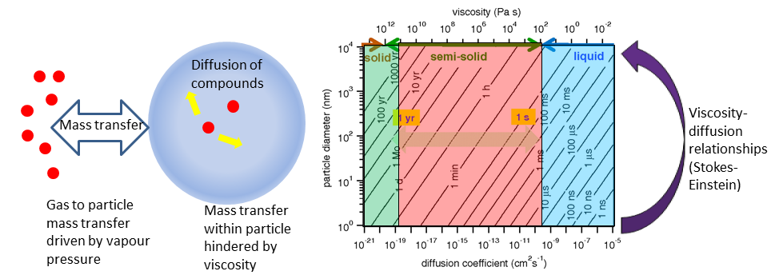

Figure 1. Viscosity, diffusion and aerosol particles. A) molecules (red) within an aerosol particle (blue) reaching equilibrium with the gas phase by mass transfer from the condensed phase and diffusion within the particle. B) The relationships for particle size, diffusion coefficient and characteristic mixing time, divided into different viscosity regimes; solid (green) semi solid (peach) and liquid (blue) from Shiraiwa (6).

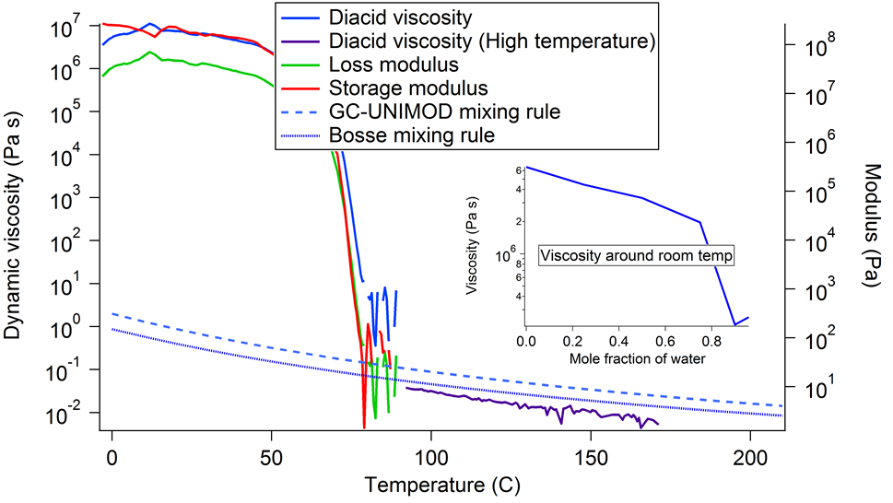

Figure 2. Dynamic viscosity, loss modulus, and elastic modulus as a function of temperature for dry diacid mix. Insert shows the viscosity at 298 K for increasing mole fractions of water incorporated into the mixture.

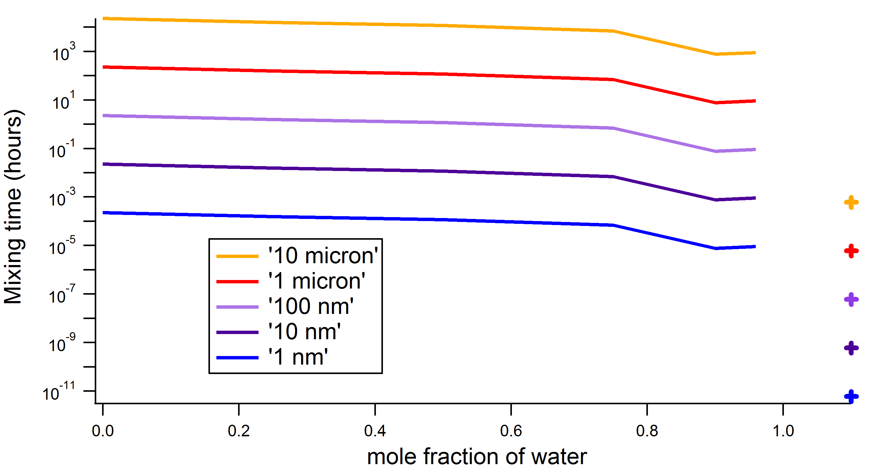

Figure 3. The characteristic mixing time for diacid mix particles of different sizes and increasing water mole fractions. Crosses denoted mixing times for the extrapolated supercooled state at room temperature.

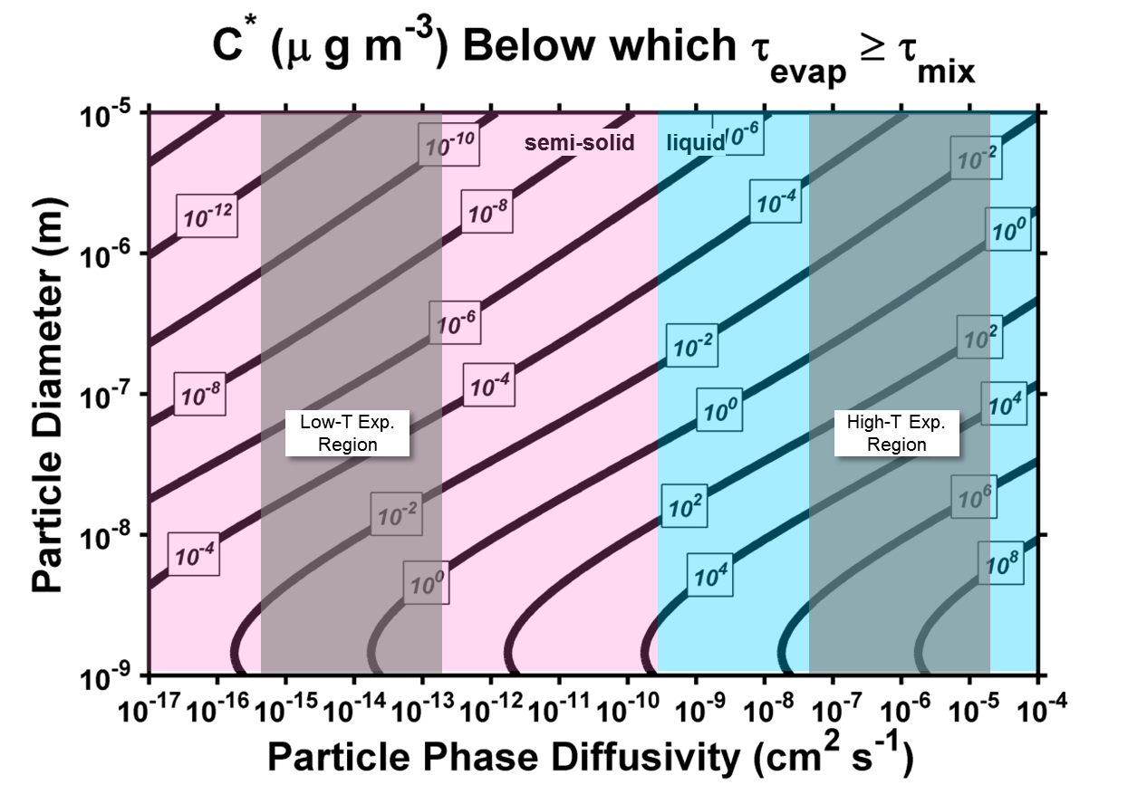

**Figure 4.** Threshold volatility, the volatility at which the timescales for equilibration due to evaporation and mixing are exactly equal, is plotted as a function of particle-phase diffusivity (D) and particle diameter. Also shown are the regions of diffusivity space relevant for liquid (blue) and semi-solid (pink) behavior. The gray, shaded regions illustrate the range of diffusivities estimated from the experimental results at low (0-90 °C) and high (>100 °C) temperatures.

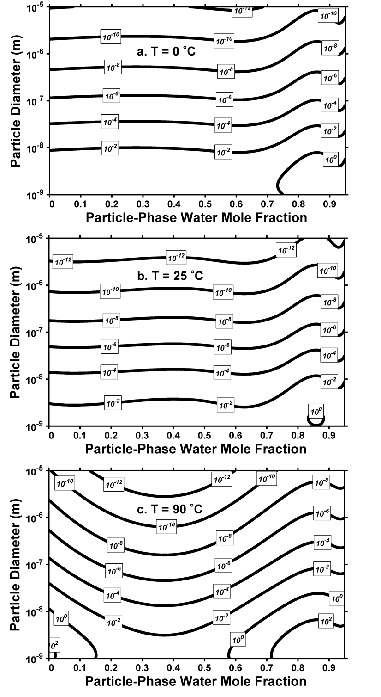

**Figure 5.** The threshold volatilities (those at which the time scales for evaporation and mixing are equal for species taken up into this experimental diacid mixture) as a function of water mole fraction and particle diameter at temperatures equal to a) 0, b) 25, and c) 90 °C. At the temperatures in panels (a) and (b) the experimental system demonstrated viscosity indicative of semi-solid phase behaviour (see fig. 3), while at the temperature in panel (c), the mixture began to transition to liquid-like behaviour.